Geochronological compilation of Trans-Hudson Orogen and environs, Baffin Island

Author: N. Wodicka

Introduction

This compilation represents published geochronological information on rocks from Trans-Hudson Orogen and adjacent Archean Rae craton in Baffin Island, Nunavut. For each dated rock sample, a record containing basic information on geological setting, rock description, sample location, analytical method, age, interpretation, and literature citation is given. The analytical methods included in the compilation are U/Pb, Pb/Pb, K/Ar, ⁴⁰Ar/³⁹Ar, and Rb/Sr. Accompanying Nd-Sm compilations are available separately on this DVD. The full geochronological compilation also forms part of the Canadian Geochronology Knowledgebase (http://gdr.ess.nrcan.gc.ca/geochron/e/explorer.htm).

The majority of published data had locations reported by latitude and longitude or by Universal Transverse Mercator (UTM) coordinates. When no sample location information was given in the original text, coordinates were estimated from available location and geological maps or from aerial photographs. It should also be noted that sample locations given in this DVD are more accurate than those shown on GSC Open File 4931 (St-Onge et al. 2006; GSC Open File 4931).

Keywords: Geochronology, Trans-Hudson Orogen, Archean, Paleoproterozoic, Baffin Island

Database Structure

To assist the user in interpreting the information provided in the compilation, a description of the fields and general principles followed in preparing the entries in database table “Baffin geochron compilation.dbf” is provided below. However, the user is encouraged to consult the original data source to verify the data and their interpretation.
[SAMPLE] - Sample number as given in the original data source or one assigned to uniquely identify the analyzed sample(s) (abbreviations used in assigned sample numbers include: Am = amphibolite; incl = inclusion; Peg = pegmatite)
[ROCK_TYPE] - Broad categorization of rock into one of four types: Plutonic, Volcanic, Sedimentary, or Metamorphic
[GEOLOCALE] - Description of the geological framework of a given sample based on St-Onge et al.’s (2006; Tectonics 25: TC4006, doi:10.1029/2005TC001907) nomenclature (see Fig. 1 below). These include the following terms:
Superior margin, Trans-Hudson Orogen
Narsajuaq terrane, Trans-Hudson Orogen
Meta Incognita microcontinent, Trans-Hudson Orogen
Rae margin, Trans-Hudson Orogen
Rae craton
Eqe Bay belt, Rae craton
Isortoq belt, Rae craton
Sub-Paleozoic Basement
[GEOLUNIT] - Main geological unit (e.g., tectonostratigraphic name, batholith name) as given in the original data source or one assigned based on location of sample on recent geological maps. A question mark (?) refers to samples for which the geological unit is uncertain.
[ROCKDESC] - Brief description of rock lithology and petrography as given in the original data source. Mineral abbreviations are after Kretz (1983; Am. Mineral. 68: 277-279) or from the listing of symbols for rock and ore-forming minerals at http://www.mineralogicalassociation.ca/doc/symbols.pdf. Additional abbreviations include: Fsp = feldspar.
[LOCATION] - Geographic location of sample (e.g., Southwest of Frobisher Bay, Meta Incognita Peninsula, southern Baffin Island)
[UTM_ZONE] - UTM Zone, NAD83
[EASTING] - UTM easting coordinate, NAD83
[NORTHING] - UTM northing coordinate, NAD83
[NTS] - NTS sheet number at the 1:50 000 scale
[AGE_MA] - The interpreted age of the rock or mineral given in millions of years (Ma). Unless otherwise indicated, pre-1977 ages have been corrected to the recommended decay constants of Steiger and Jäger (1977; EPSL 36: 359-362).
[ERR_PLUS] - 2 sigma positive uncertainty in Ma. This uncertainty is 0 when no error is given in the original data source.
[ERR_MINUS] - 2 sigma negative uncertainty in Ma. This uncertainty is 0 when no error is given in the original data source.
[AGE_METHOD] - Isotopic system or methodology used to derive the age (e.g., U/Pb, Rb/Sr, K/Ar, etc.).
[AGE_MATER] - The mineral (e.g., zircon, monazite, etc.) or material (e.g., whole rock) analyzed
[AGE_INTERP] - A general category that describes the type of geological event dated (e.g., cooling, igneous crystallization, etc.). “No Age” refers to ages for which a unique interpretation is not possible.

[AGE_QUALI] - A qualifier describing constraints on the age. "Direct" refers to analytical errors that are statistically representative; "Estimate" is used when the author(s) indicate no statistical validity to assigned errors. Other qualifiers include "Maximum Direct" (i.e. statistical limit on how old the sample can be) and "Minimum Direct" (i.e. statistical limit on how young the sample can be)
[AGE_TECHNI] - The analytical technique used to determine the age (e.g., SHRIMP, TIMS)
[AGE_NOTE] - A text descriptor highlighting salient features used by the author(s) in arriving at the published interpretation of the date. These features may include brief analytical details (e.g., quality of separate in the case of K/Ar ages), number of data points used in regression calculations, type of regression where given, quality of fit for regressed data or weighted averages, uncertainties in age interpretations, etc. Abbreviations used include: LI = Lower intercept; MSWD = Mean Standard Weighted Deviation; UI = Upper intercept
[AUTHORS] - Author(s) of data source
[YEAR] - Year of publication
[TITLE] - Title of publication (blank if a thesis)
[JOURNAL] – Title of Journal, Government report, or thesis
[VOLUME] – Volume of Journal (0 if a report, map, or Journal in press)
[FIRST_PAGE] – First page number of Journal publication or Government report (or total number of pages for a thesis; 0 if a map or Journal in press)
[LAST_PAGE] - Last page number of Journal publication or Government report (0 if a map, thesis, or Journal in press)

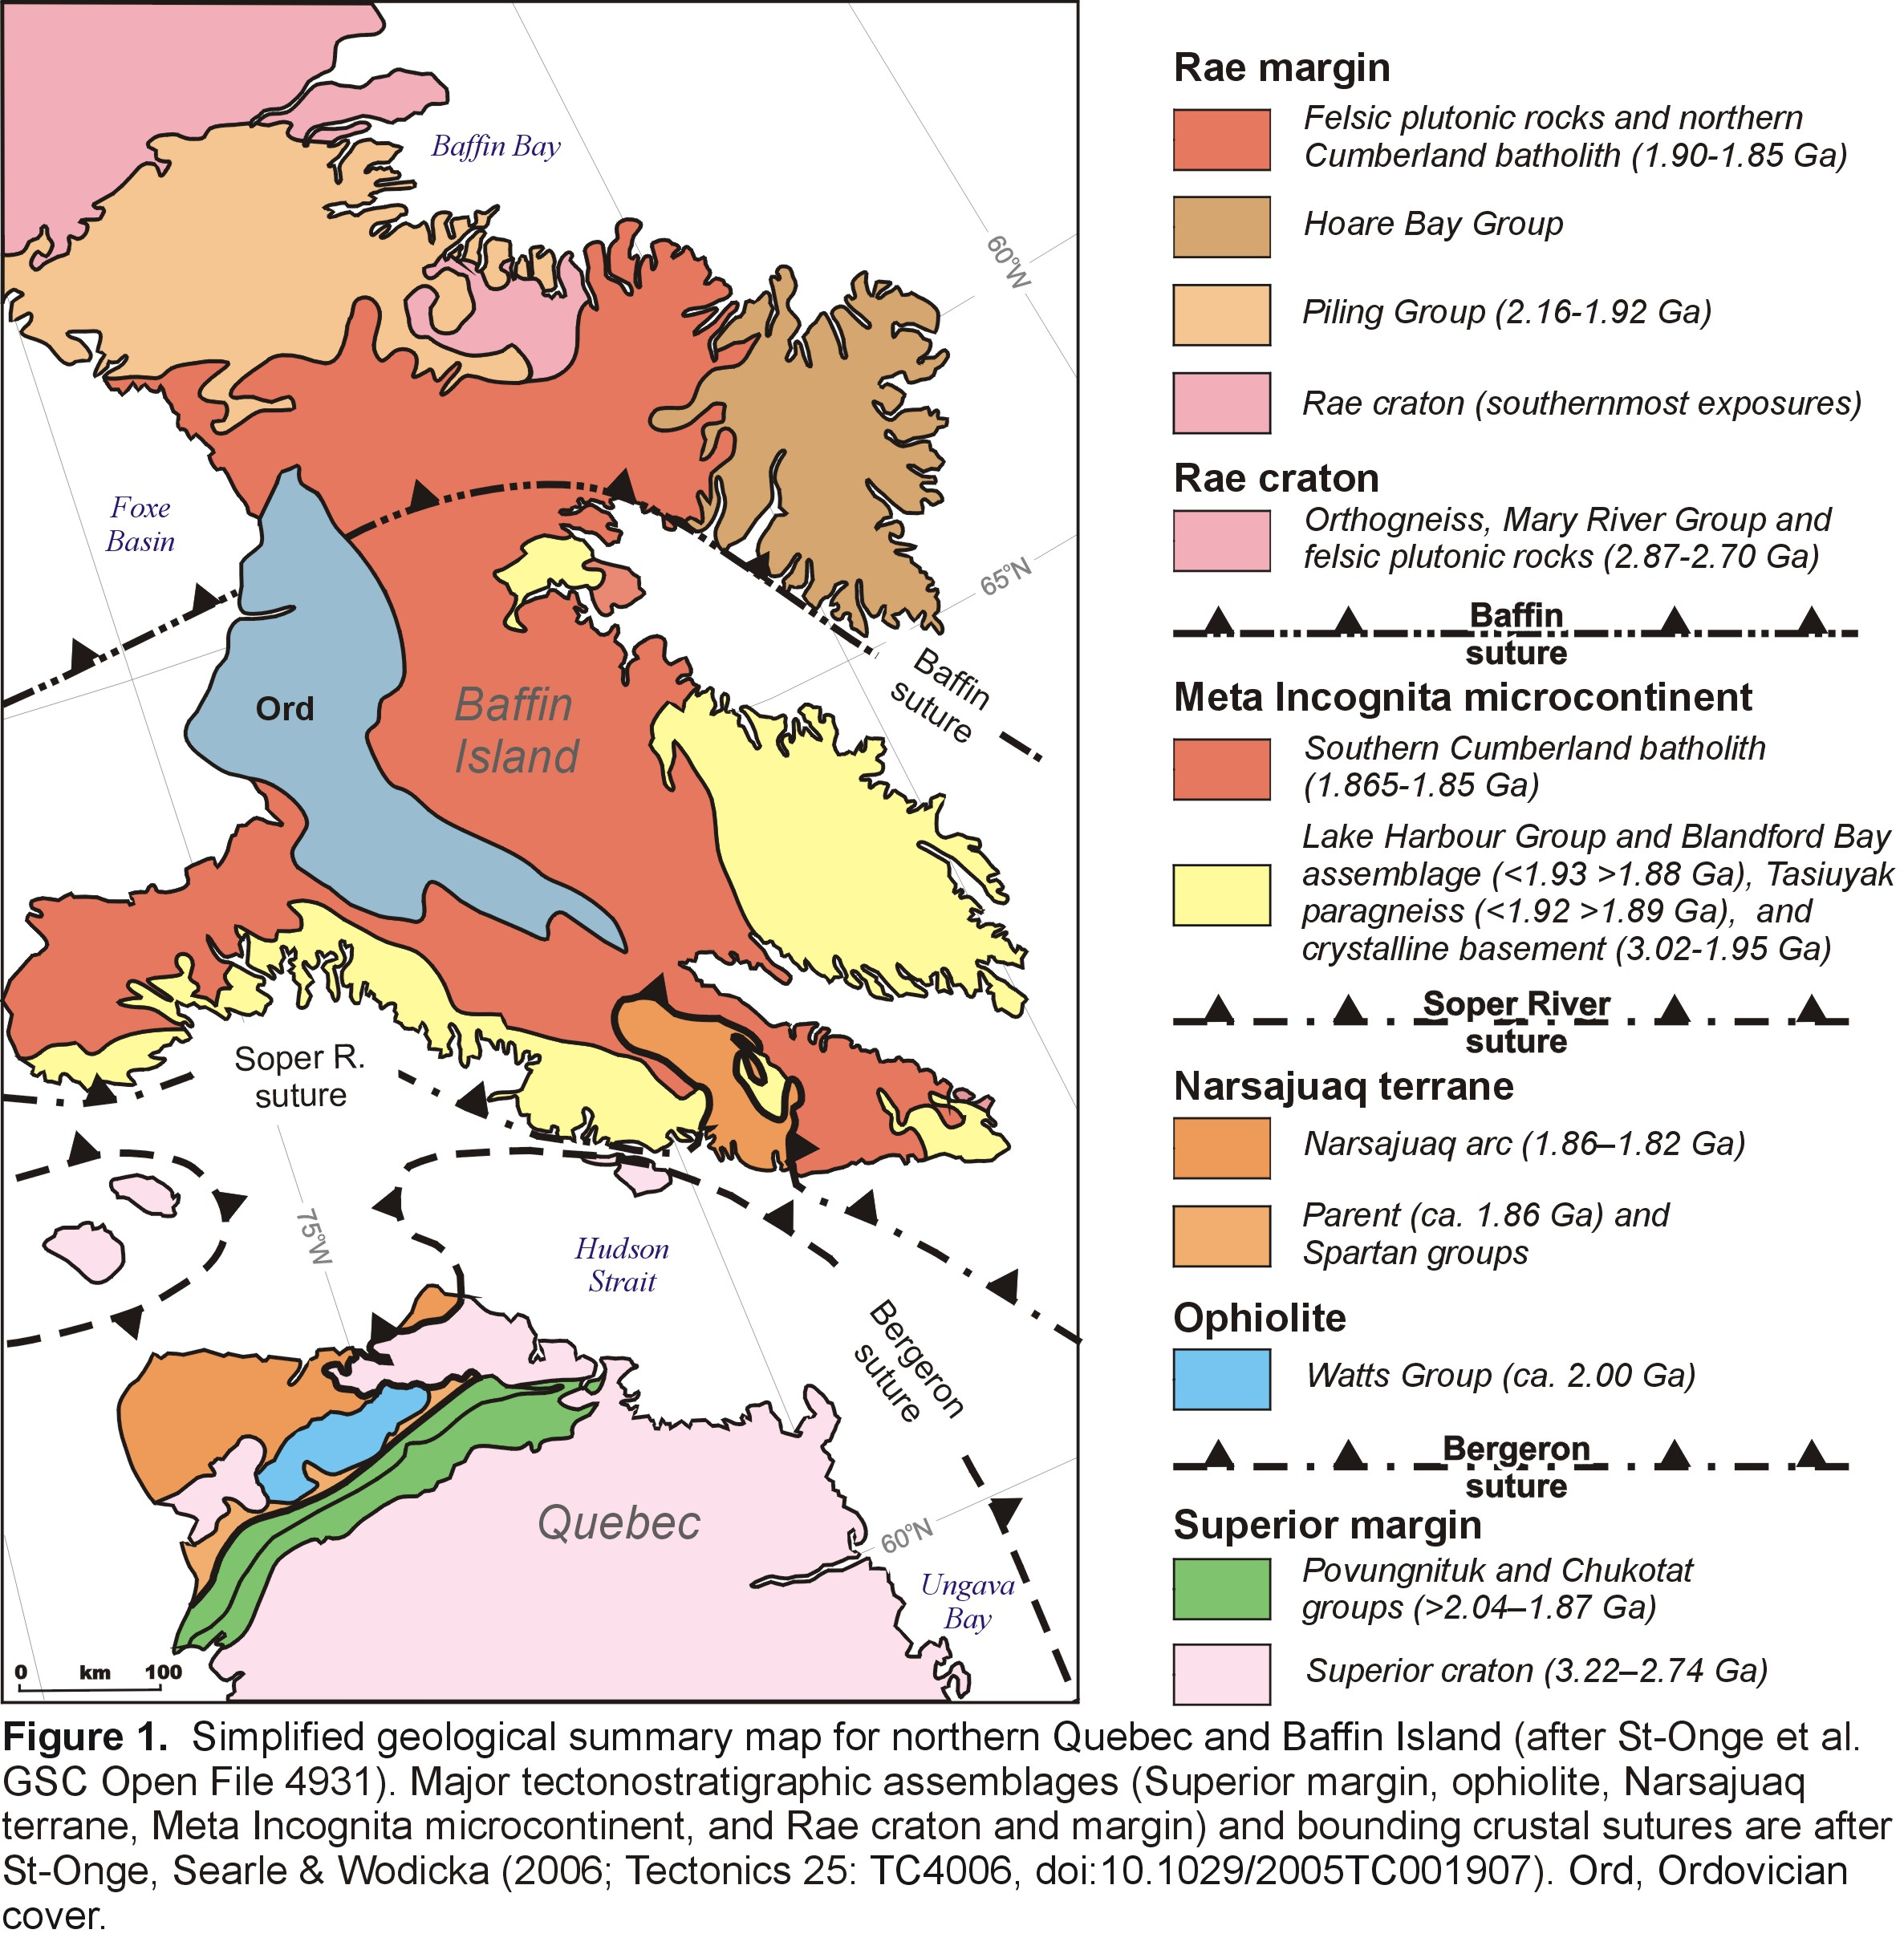

Corrections and Additions

Every attempt was made to include all published radiometric ages but as with any database there are undoubtedly omissions or mistakes. If you detect any ages that should be included in this compilation or any mistakes, please send the information to the attention of Natasha Wodicka, Natural Resources Canada, Geological Survey of Canada, 601 Booth Street, Ottawa, ON, Canada K1A 0E8. Phone (613) 947-4795; Fax: (613) 995-7997; E-mail: nwodicka@nrcan.gc.ca

Acknowledgements

Sarah McMullen contributed greatly to the early stages of this compilation. Eric de Kemp, Angela Ford, Ingrid Henderson, Mike Villeneuve, and Linda Richard provided invaluable computer assistance. We would also like to thank Marc St-Onge for providing sample location information from aerial photographs.

Data Sources

Bethune, K.M., and Scammell, R.J. 1997: Precambrian geology, Koch Island area, District of Franklin, Northwest Territories, (part of NTS 37C). Geological Survey of Canada, Open File 3391, scale 1:50 000.

Bethune, K.M., and Scammell, R.J. 2003a: Distinguishing between Archean and Paleoproterozoic tectonism, and evolution of the Isortoq fault zone, Eqe Bay area, north-central Baffin Island, Canada. Canadian Journal of Earth Sciences, 40: 1111-1135.

Bethune, K.M., and Scammell, R.J. 2003b: Geology, geochronology, and geochemistry of Archean rocks in the Eqe Bay area, north-central Baffin Island, Canada: constraints on the depositional and tectonic history of the Mary River Group of northeastern Rae Province. Canadian Journal of Earth Sciences, 40: 1137-1167.

Copeland, D.A. 1999: The structural and metamorphic geology of Big Island, southwest Baffin Island, Nunavut Territory. Unpublished M.Sc. thesis, University of New Brunswick, Fredericton, New Brunswick, 328 p.

Hemming, S.R., Gwiazda, R.H., Andrews, J.T., Broecker, W.S., Jennings, A.E., and Onstott, T.C. 2000: 40Ar/39Ar and Pb-Pb study of individual hornblende and feldspar grains from southeastern Baffin Island glacial sediments: implications for the provenance of the Heinrich layers. Canadian Journal of Earth Sciences, 37: 879-890.

Henderson, J.R., and Loveridge, W.D. 1981: Age and geological significance of a tonalite pegmatite from east-central Baffin Island. In Rb-Sr and U-Pb Isotopic Age Studies, Report 4. Current Research, Part C, Geological Survey of Canada, Paper 81-1C, pp. 135-137.

Hunt, P.A., and Roddick, J.C. 1987: A compilation of K-Ar ages, Report 17. Radiogenic Age and Isotopic Studies: Report 1, Geological Survey of Canada, Paper 87-2, 143-210 p.

Jackson, G.D. 1978: McBeth Gneiss Dome and associated Piling Group, central Baffin Island, District of Franklin. In Rubidium-Strontium Isotopic Age Studies, Report 2 (Canadian Shield). Edited by R.K. Wanless, and W.D. Loveridge. Geological Survey of Canada, Paper 77-14, pp. 13-17.

Jackson, G.D., Hunt, P.A., Loveridge, W.D., and Parrish, R.R. 1990: Reconnaissance geochronology of Baffin Island, N.W.T. In Radiogenic Age and Isotopic Studies: Report 3, Geological Survey of Canada, Paper 89-2, pp. 123-148.

Lowdon, J.A. 1960: Age Determinations by the Geological Survey of Canada, Report 1 - Isotopic Ages; Geological Survey of Canada, Paper 60-17, 51 p.

Lowdon, J.A., Stockwell, C.H., Tipper, H.W., and Wanless, R.K. 1963: Age Determinations and Geological Studies (Including Isotopic Ages - Report 3); Geological Survey of Canada, Paper 62-17, 140 p.

Pidgeon, R.T., and Howie, R.A. 1975: U-Pb age of zircon from a charnockitic granulite from Pangnirtung on the east coast of Baffin Island. Canadian Journal of Earth Sciences, 12: 1046-1047.

Scott, D.J. 1997: Geology, U-Pb, and Pb-Pb geochronology of the Lake Harbour area, southern Baffin Island: implications for the Paleoproterozoic tectonic evolution of northeastern Laurentia. Canadian Journal of Earth Sciences, 34: 140-155.

Scott, D.J. 1997: Preliminary U-Pb geochronology of the Hall Peninsula east of Iqaluit, southern Baffin Island. In Radiogenic Age and Isotopic Studies: Report 10; Geological Survey of Canada, Current Research 1997-F, pp. 67-78.

Scott, D.J. 1999: U-Pb geochronology of the eastern Hall Peninsula, southern Baffin Island, Canada: a northern link between the Archean of West Greenland and the Paleoproterozoic Torngat Orogen of northern Labrador. Precambrian Research, 93: 5-26.

Scott, D.J., and Gauthier, G. 1996: Comparison of TIMS (U-Pb) and laser ablation microprobe ICP-MS (Pb) techniques for age determination of detrital zircons from Paleoproterozoic metasedimentary rocks from northeastern Laurentia, Canada, with tectonic implications. Chemical Geology, 131: 127-142.

Scott, D.J., and Wodicka, N. 1998: A second report on the U-Pb geochronology of southern Baffin Island, Northwest Territories. In Radiogenic Age and Isotopic Studies: Report 11; Geological Survey of Canada, Current Research 1998-F, pp. 47-57.

Stevens, R.D., Delabio, R.N., and Lachance, G.R. 1982: Age Determinations and Geological Studies, K-Ar Isotopic Ages, Report 16; Geological Survey of Canada, Paper 82-2, 56 p.

Stern, R.A., and Berman, R.G. 2000: Monazite U-Pb and Th-Pb geochronology by ion microprobe, with an application to in situ dating of an Archean metasedimentary rock. Chemical Geology, 172: 113-130.

Stern, R.A., and Sanborn, N. 1998: Monazite U-Pb and Th-Pb geochronology by high-resolution secondary ion mass spectrometry. In Radiogenic Age and Isotopic Studies: Report 11; Geological Survey of Canada, Current Research 1998-F, pp. 1-18.

St-Onge, M.R., Wodicka, N., and Ijewliw, O. in press: Polymetamorphic evolution of Trans-Hudson Orogen on Baffin Island, Canada: Constraints from Petrology, Structure, and U-Pb Dating. Journal of Petrology.

Wanless, R.K., Stevens, R.D., Lachance, G.R., and Delabio, R.N. 1972: Age Determinations and Geological Studies, K-Ar Isotopic Ages, Report 10; Geological Survey of Canada, Paper 71-2, 96 p.

Wanless, R.K., Stevens, R.D., Lachance, G.R., and Delabio, R.N. 1978: Age determinations and geological studies, K-Ar isotopic ages, Report 13; Geological Survey of Canada, Paper 77-2, pp. 35, 36, 41, 42.

Wanless, R.K., Stevens, R.D., Lachance, G.R., and Delabio, R.N. 1979: Age Determinations and Geological Studies, K-Ar Isotopic Ages, Report 14; Geological Survey of Canada, Paper 79-2, 67 p.

Wanless, R.K., Stevens, R.D., Lachance, G.R., and Delabio, R.N.D. 1974: Age Determinations and Geological Studies, K-Ar Isotopic Ages, Report 12; Geological Survey of Canada, Paper 74-2, 72 p.

Wanless, R.K., Stevens, R.D., Lachance, G.R., and Edmonds, C.M. 1968: Age Determinations and Geological Studies, K-Ar Isotopic Ages, Report 8; Geological Survey of Canada, Paper 67-2, Part A, 141 p.

Wanless, R.K., Stevens, R.D., Lachance, G.R., and Rimsaite, J.Y.H. 1966: Age Determinations and Geological Studies, K-Ar Isotopic Ages, Report 6; Geological Survey of Canada, Paper 65-17, 101 p.

Wodicka, N., and Scott, D.J. 1997: A preliminary report on the U-Pb geochronology of the Meta Incognita Peninsula, southern Baffin Island, Northwest Territories. In Current Research 1997-C; Geological Survey of Canada, pp. 167-178.

